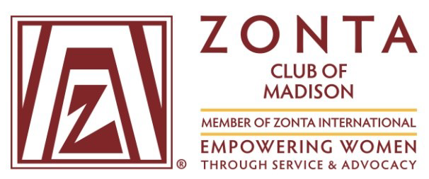
Bring the Basics. Period.
Zonta Club of Madison’s mission is to empower women and girls through service and advocacy.
This year our major service project is called Bring the Basics. Period.
Did you know?
Did you know that there are many women and girls who miss days of work or school for as much as one week each month because they do not have access to pads and tampons?
Imagine fifth grader Layla. She lives in a small apartment with her Mom and two older sisters. Layla’s Mom works a full -time job, but finds it difficult to stretch her paycheck to cover rent and utilities. If her car breaks down or there is an unexpected trip to the doctor with one of the girls, she comes up short. She reluctantly relies on food pantries occasionally to make sure they have enough food to get through until payday.
Period products are expensive, and are not readily available at food banks, shelters, schools and other places with high need. When families are struggling to put food on the table, it may be difficult to find the extra money for period supplies. With four females in the household, this is no small expense.
That’s why students like Layla and her sisters miss school when they have their period. It is easier to stay home than to face potential embarrassment at school.
Sadly, Layla’s family is not alone.
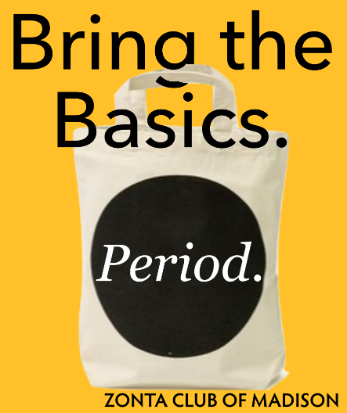
According to a 2017 study by Always®, a brand of period products, period poverty means that 1 in 5 US girls miss school during their monthly cycle.
Zonta Club of Madison surveyed 20 different agencies in the Madison area that offer services for those in need. The response? Almost every agency expressed a strong need for products in our community.

What is Zonta Club of Madison’s plan?
Zonta’s service committee will organize the collection and distribution of period products. We will buy, collect and deliver period products to local agencies that serve families in need.
How can you help?
- Make a financial donation to Zonta Club of Madison by writing a check to ZONTA MADISON FOUNDATION. Donations are tax deductible.

- Gather a group of people from your workplaces, church group, book club, sports team, neighborhood, or friends and have a “party” to gather products.
Zonta has come up with some creative ideas to give you ideas and help you organize an event on our website at http://www.zontaofmadison.org/bring-the-basics-period/
- Place a collection box at your work place.
We will be collecting and distributing products from now until June, 2020. Contact us at zontamadisonservice@gmail.com to arrange for us to pick up products.

Be one of our Zonta 100 Champions
We are looking for people or organizations that will agree to be a Zonta 100 Champion. In honor of Zonta’s 100th birthday, we will recognize and celebrate our champions. Watch our website for further details!
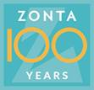

Learn more about Zonta and the work we do at our website:
http://www.zontaofmadison.org.
Learn more about the Bring the Basics. Period. project at:
http://www.zontaofmadison.org/bring-the-basics-period/

